Technical Seminar on Digital Works Supervision System (DWSS)
By Mr Tom Lui

The technical webinar on Digital Works Supervision System (DWSS) was held on August 30, 2023. Presented by the CEO of dRoW Ir C K Ng, the webinar revolved around the integrated Common Data Environment (CDE).
Ir Ng kicked off by putting the spotlight on the increased importance of the DWSS. Starting from April 1, 2023, all new contracts above 30M under the capital work program of the Development Bureau require the adoption of DWSS. DWSS is a centralized management approach through a dedicated digital platform, streamlining the processes in the area such as contract management, quality control and site management.
A significant focus of the seminar centred on integrating Artificial Intelligence (AI) into NEC processes. Particularly noteworthy was the potential role of OpenAI in guiding new workers and engineers. The vision is to utilize AI as a guide that assists newcomers in grasping the entirety of a project while aiding in problem-solving with precise information. This innovation is promising in streamlining project understanding and troubleshooting, ultimately bolstering efficiency and knowledge transfer.
DWSS's evolution and AI's role in harnessing its data were explored. Ir Ng lead the attendees delved into the benefits and implications of converging Building Information Modeling (BIM), DWSS, and NEC for seamless project operations.
The seminar prompted dynamic discussions on integration complexities, BIM's synergistic potential, and the applicability of ISO19650 within DWSS. The event underscored the value of a Centralized Management Platform for harmonizing processes and synchronizing various systems.
In summary, the seminar exemplified the construction industry's transition towards unified data frameworks. It fostered insightful exchanges, uniting stakeholders in collectively advancing industry practices. The seminar's emphasis on AI's role in guiding and problem-solving showcased a forward-looking approach to efficient project management within the dynamic construction landscape.

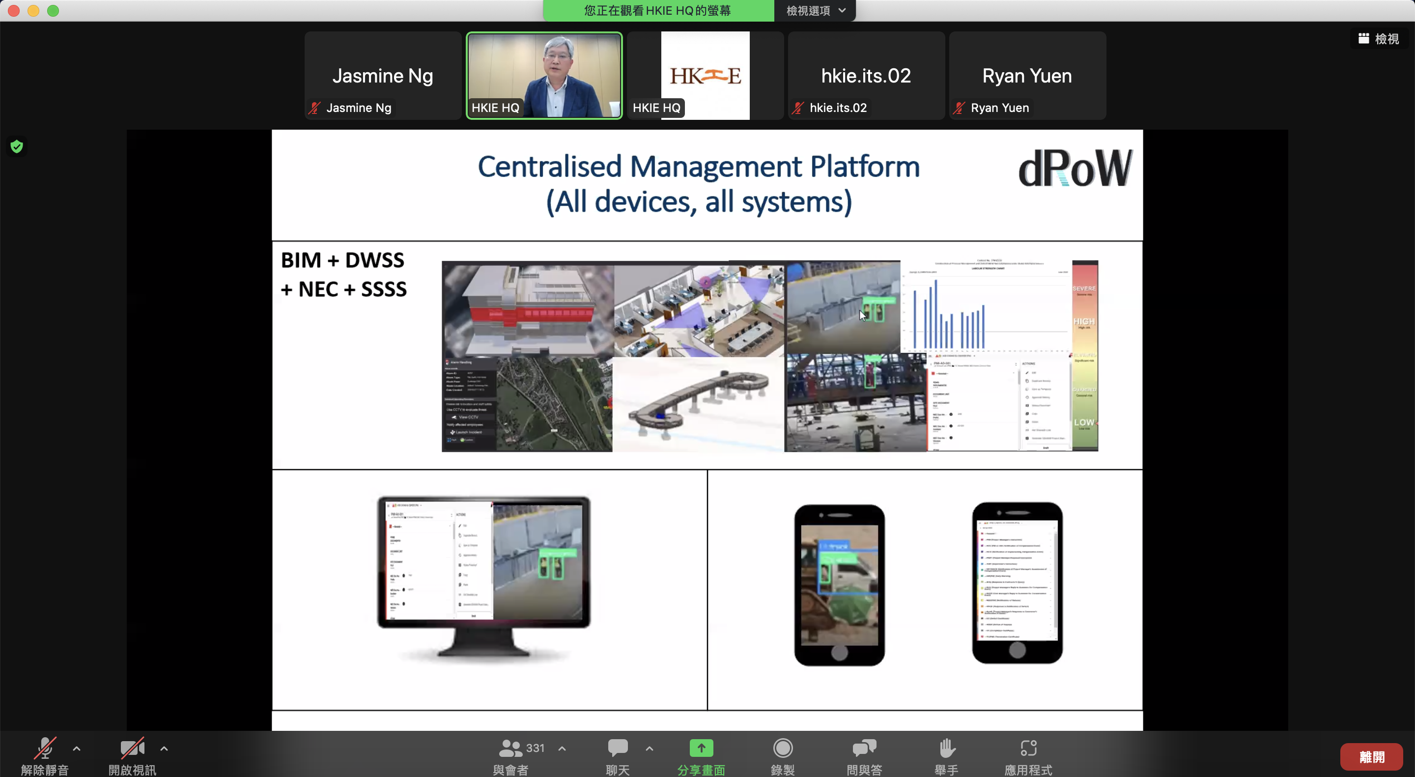
Ir C K Ng illustrated how the Centralized Management Platform can harmonize processes and synchronize various systems

