Technical Seminar on Artificial Intelligence (AI) on Search and Rescue
By Mr. Alan Cheng

In recent years, there has been a surge in cases of missing hikers requiring extensive searching efforts in the mountains. Mr. Max Lee, Co-Founder and CTO of LifeSparrow Solutions Limited, delivered a comprehensive presentation on 10 January 2024 sharing his insights on the application of Artificial Intelligence (AI) to assist in Search and Rescue (SAR) operations in mountainous areas.

Mr. Lee began the seminar by introducing the statistics of local hiking incidents and discussing the crucial factors contributing to successful SAR operations. He then compared the advantages and disadvantages of current technologies used in mountain SAR, including cellular triangulation, drones with IMSI Catcher, and drones with Wi-Fi Detection. Recognizing the limitations of conventional approaches, Mr. Lee introduced his innovative AI solutions for SAR, centred around effective drone image analysis. He provided a detailed breakdown of the algorithms and designs behind this solution. The AI model was based on RTMDet, Sliced Inference and test time augmentation. He also showcased a recent collaboration with the Fire Services Department, highlighting the application of this technology in assisting local SAR cases. Furthermore, Mr. Lee elaborated how AI could enhance the SAR operations by comparing with other existing method, such as infrared drone imagery analysis and Infrared Synthetic Aperture Sensing.

This seminar shed light on the uncommon field of AI application in search and rescue, revealing the tremendous potential of AI technology in safeguarding lives. We were also impressed by the strong commitment to social responsibility demonstrated by Mr. Lee in improving SAR services. On behalf of YMC, we express our sincere gratitude to Mr. Lee for his informative presentation.

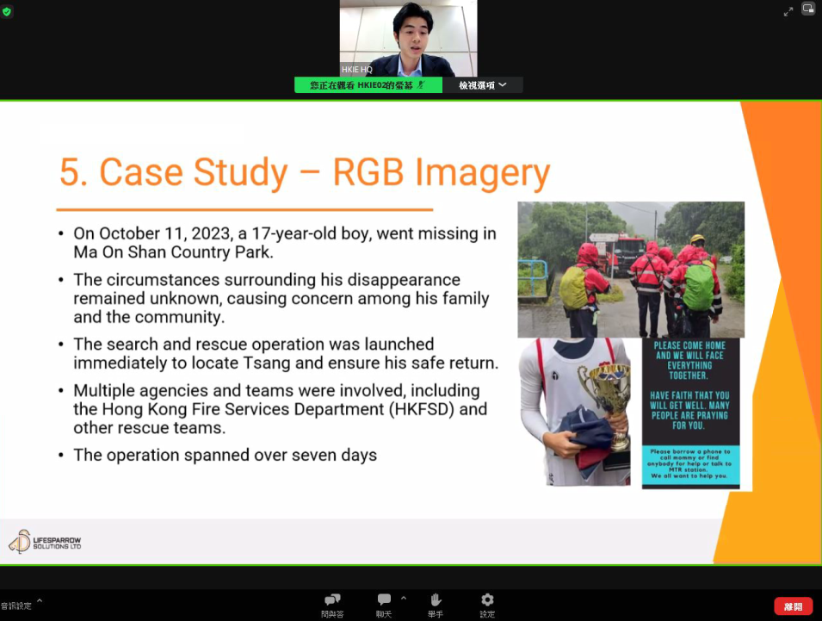
<Photo Caption: Mr. Max Lee, the speaker, is presenting a case study on the application of Artificial Intelligent positioning technology in search and rescue operations conducted by the Fire Services Department.>

