Sharing Session on the Spirit of Entrepreneurship with Successful AI-Driven Ventures
By Mr. Nathan LAM
On 22 August 2025, the Hong Kong Institution of Engineers Young Members Committee (HKIE YMC) successfully hosted a dynamic sharing session titled “Sharing Session on the Spirit of Entrepreneurship with Successful AI-Driven Ventures” at the Chan Yat Mei Sophie Room, the HKIE headquarters. The event, attended by 20 participants, featured Mr. Tom Mong, a serial entrepreneur renowned for his AI-driven ventures across construction, education, marketing, and community platforms.
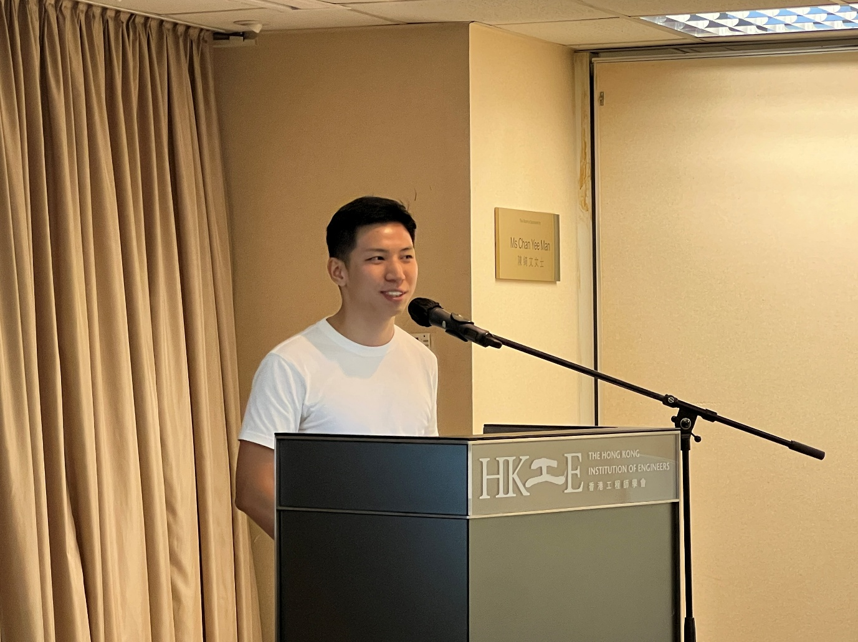
Sharing Session held successfully at the Chan Yat Mei Sophie Room, the HKIE headquarters
Mr. Mong captivated the audience with insights from his entrepreneurial journey, emphasizing the mindset and strategies behind his recent successes, his café and bar discovery apps, which soared to the top places in Hong Kong’s app store within a few days after their launch. Rather than delving into technical details, he focused on practical approaches to leveraging AI as a “co-pilot” for innovation, rapid market entry, and user-centric design. He demonstrated how the application can quickly be developed and launched to the market in a few days’ time. Furthermore, he also shared the way to promote new ideas through effective use of social media to generate impact within the community.
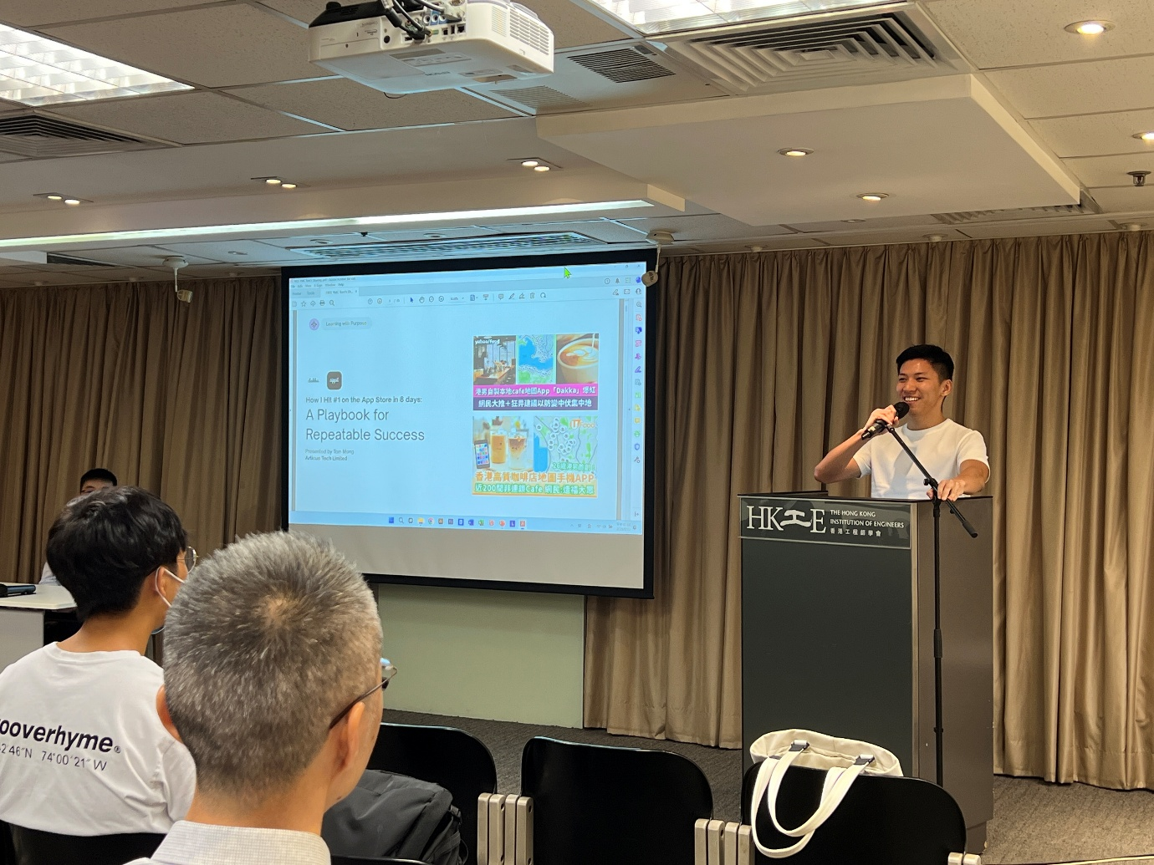
Sharing from a first-person perspective on mobile applications development
As a step further on his storey of mobile application development, he encouraged engineers and aspiring entrepreneurs to adopt an agile, problem-solving mindset, instead of being too focused on technical matters. Using the examples of other fellow entrepreneurs, who developed applications successfully using AI platforms only, he motivated engineers to make use of their strength to develop into new ideas in action, whereas technical barriers can greatly be solved nowadays with the assistance of AI.

The event, as the inaugural seminar of session 2025/26 for HKIE YMC, has shared a different topic from ordinary seminars. Attendees praised Mr. Mong’s candid delivery and actionable advice, sparking discussions on integrating AI into professional paths. This inspiring session left participants motivated to explore AI-driven innovation, and the HKIE YMC looks forward to hosting more events to foster entrepreneurship among its members.
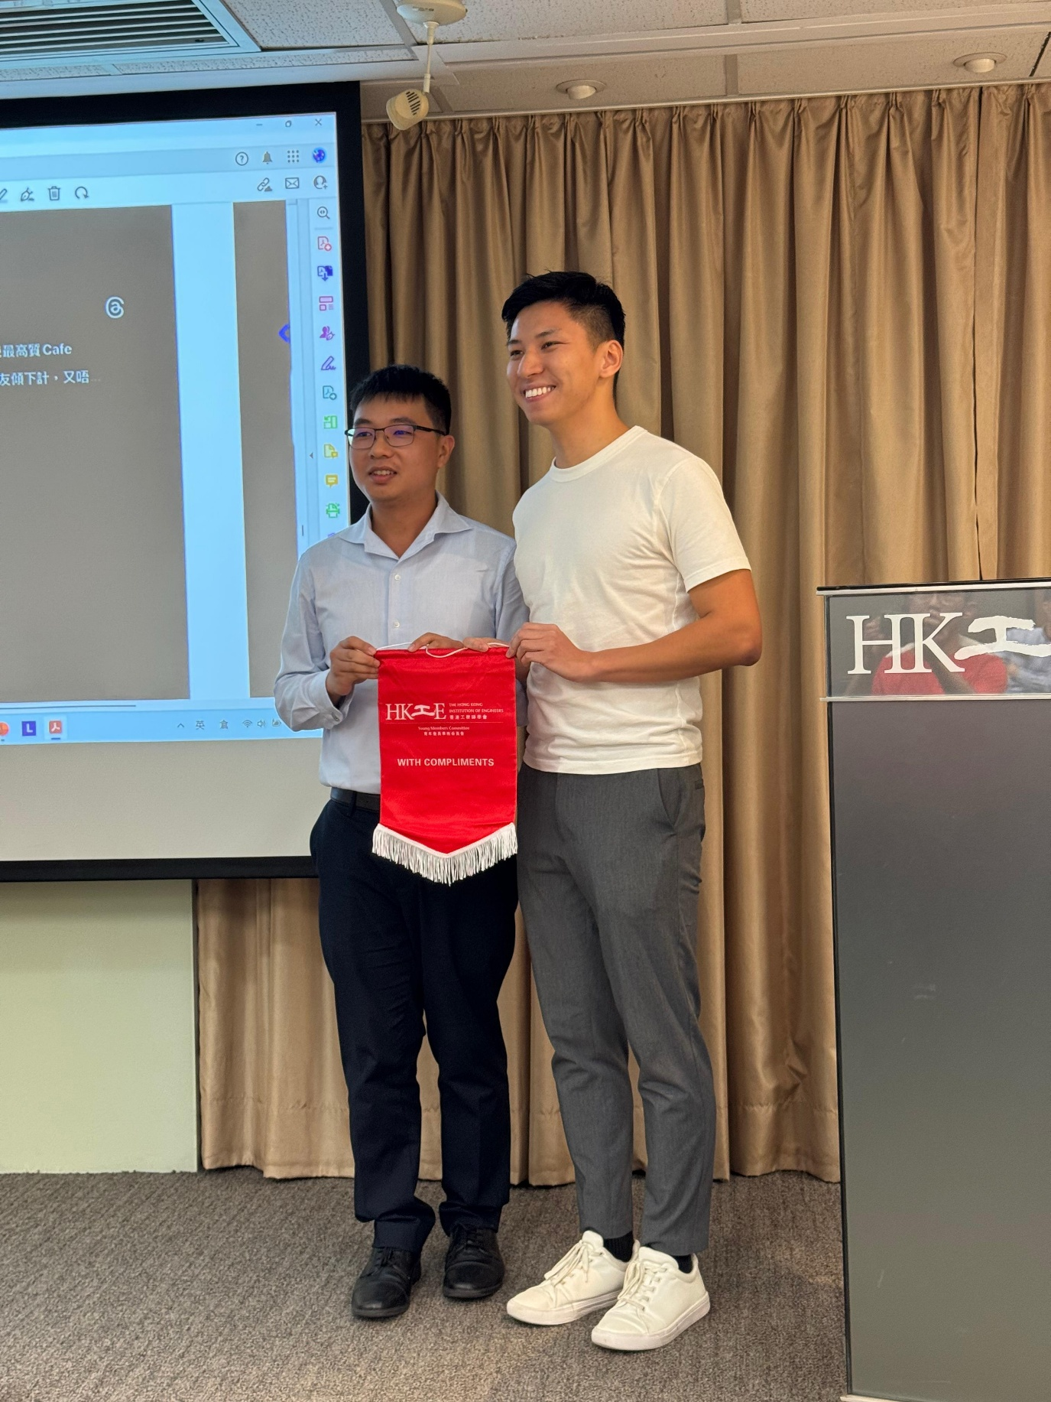
Souvenir presentation to the speaker

